cc

Weekly Surveillance Reports: <https://www.who.int/emergencies/diseases/meningitis/epidemiological/en/>

Meningitis is found in two forms: bacterial and viral – will focus on bacterial which is significantly more dangerous

Meningococcal meningitis, caused by *Neisseria meningitidis* bacteria, is of particular importance due to its potential to cause large epidemics.

Six serogroups which can cause epidemics are: A, B, C, W, X & Y

**Q. What is meningitis?**

- inflammation of membranes near brain and spinal cord

* Within 2 days, if not treated, can lead to severe brain damage and in some instances death

Type: Bacterial

Conclusion: Can spread from large gatherings

Neighboring Countries: Mali, Niger, Côte D’Ivoire, Benin, Togo

Total population: 19.19 million

Number of muslims: 12.45 million

90% of population works in farming

**Religion**

Main religion: Muslim (60.5%)

Avg number per mosque is 2000 – number who visit every Friday

Assume around 500 go 3 times a week

Total no. of mosques = 165

Possible diseases correlation with meningitis:

* Respiratory infections
* 1 in 10 are carriers
* **Lower Respiratory Infections** 14% - *correlated*
* **Malaria** 10%
  + <http://www.who.int/wer/archives/en/>
  + Analysis of malaria
* Diarrheal disease 6%
* Stroke 6%
* Preterm Birth Complications 4%
* **Ischaemic Heart Disease** 4%
* **Meningitis** 4%

Bacterial vs. Viral Meningitis

* [Viral meningitis](http://www.cdc.gov/meningitis/viral.html) is generally not life-threatening and may resolve without specific t treatment.
* **Bacterial meningitis**can be more serious than viral meningitis because its onset is rapid and infection is associated with a significant risk of death. Many survivors of bacterial meningitis have long-term disabilities, such as loss of limb(s), deafness, nervous system problems, or brain damage.

Interesting Discoveries

* Study found in 2009 that a person diagnosed with Meningitis lead to a family expenditure of $90 which often resulted in pushing families below poverty line

**In 2010, Burkina Faso vaccinated their entire age 1-29 population meningicocal**

* Vaccine protection only lasts two years

Pros of logistic regression

* Simplifies problem – linear regression will be very volatile in predictions
* Allows categorical variables to be used, e.g. things like whether there are frequent gatherings, effect of religion etc.
* Allows focus to be more on location
  + *What would be more useful?*
    - *Knowing the risk of outbreak in a location with some categorical representation e.g. high, low extreme etc.*
    - *Knowing a predicted number of cases*

**Most crowded cities in Burkina Faso**

**NOTE – From reports, it seems Ghana & Côte d’Ivoire have high number of meningitis cases**

1. Capital – Ouagadougou
   1. > 2.2 million
2. Bobo-Dioulasso
   1. >540,000
3. Ouahigouya
   1. >130,000
4. Banfora
5. Kaya (reached alert threshold of

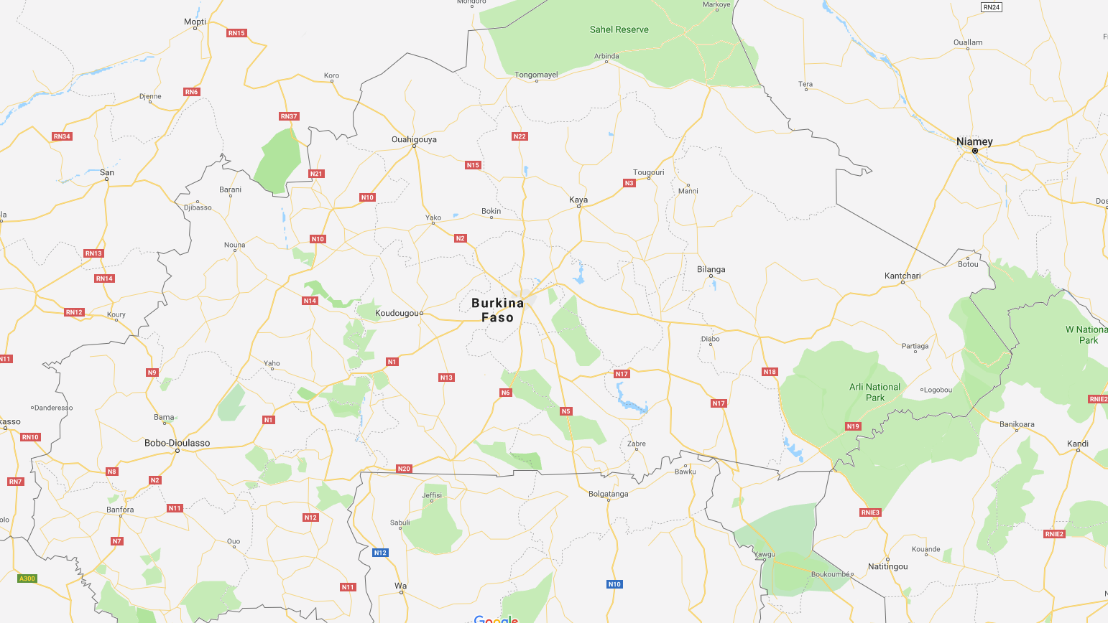

**Meningococcal Meningitis**

* Bacterial disease
* Spread by droplets of throat or respiratory secretions

**What defines an outbreak**

* Epidemic threshold is 10 per 100,000

**CFR – Case Fatality Rate (number of deaths of people who people who had meningitis)**

**Logistic Regression**

* Used when the dependent variable is categorical (e.g. is the email spam – 1 – or not spam, is the image a cat or a dog etc.)
* Interested in multinomial (3 categories) or ordinary logistic regression (more than 3 categories)
* Must determine what categories there will be
  + Q1. How best to classify the intensity of outbreaks – e.g. low / medium / high?

Big Picture:

* Have a function (usually linear like y= Wx + b) and we are trying to adjust weights and biases
* To find the best weights and biases we compute a cost function – for linear regression, this is the mean squared (difference between actual value and predicted value squared)
* Key difference between linear regression and logistic regression is that the initial continuous values we get from multiplying the weights with x + bias – we need to convert them into a probability distribution, which we do with the sigmoid function (do this before applying cost function)
* We cannot use this cost function for logistic regression, so instead we use a different one
* Now we need to minimize this cost function – to do this we can use any optimization algorithm, usually gradient descent
* In gradient descent, we compute the partial derivatives of the cost function with respect to the weights and biases and adjust them accordingly (by multiplying it by partial derivative * learning rate)
* Once we have these partial deriatives, we adjust weights (and biases) by doing Winital – partial derivative (since we are always moving in negative gradient direction for gradient descent)

Good explanation for gradient descent (<https://towardsdatascience.com/understanding-the-mathematics-behind-gradient-descent-dde5dc9be06e>)

Good explanation for logistic regression:

<https://towardsdatascience.com/logistic-regression-detailed-overview-46c4da4303bc>

**Dynamic Bayesian Network**

**Bayesian Network**

**Markov Chain**